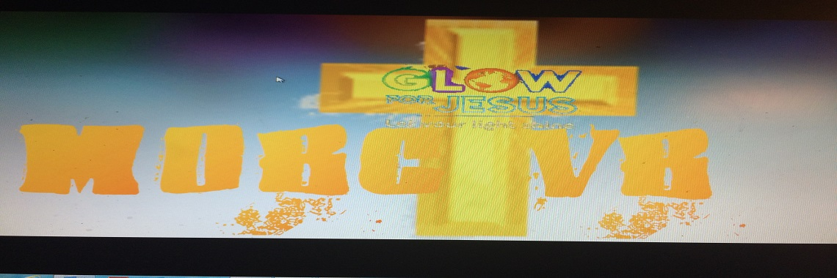

Vacation Bible School!

DATE: June 12-15, 2017
TIME: 6-8 p.m.

Feeding Time
5:00-5:45 p.m.
